USEFUL TELEPHONE NUMBERS

Lower Farm Health Centre | 01922 476640
NHS England – Complaints | 0300 311 2233
Walsall CCG Jubilee House | 01922 618388
Citizens Advice Bureau | 0300 330 1159
NHS 111 Service | 111
NHS Urgent Care Centre Walsall | 01922 656391
Patient Experience Team | 0300 311 2233
Ring and Ride | 0330 053 8136
OurNet Health Services | 01922 501999

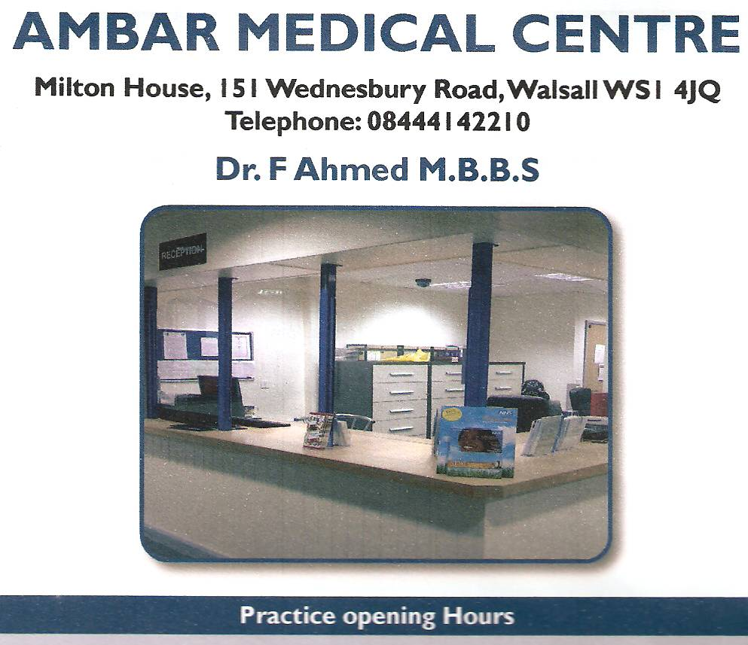
LOWER FARM HEALTH CENTRE

Dr Hammad Lodhi MBBS MRCGP

109 Buxton Road, Bloxwich, Walsall, West Midlands, WS3 3RT
TELEPHONE: 01922 476640

PRACTICE OPENING HOURS

MON | 0800am – 1830pm
TUE | 0800am – 1830pm
WED | 0800am – 1830pm
THU | 0800am – 1830pm(1300pm to 1830pm, we are subcontracted to OurNet Health Services)
FRI | 0800am – 1830pm
SAT | CLOSED
SUN | CLOSED

Practice telephone lines are open from 8:00 am

Please note, we are closed Bank holidays

https://www.ambarmedical-lowerfarm.nhs.uk/news/

Lower Farm Health Centre is not a Teaching Practice

Milton House, 151 Wednesbury Road, Walsall WS1 4JQ
Telephone 01922 626300
Dr H Lodhi MBBS MRCGP

Monday to Thursday: 8.30am – 6.30pm
Friday: 8.30am – 12pm

PRACTICE NURSES

Practice Nurses are qualified and registered nurses. They can help with health issues such as family planning, healthy living advice, blood pressure checks and wound dressings. The Practice Nurses run clinics for long-term health conditions such as Asthma or Diabetes, Minor Ailment Clinics and Cervical Smears.

ANTENATAL CLINICS

Antenatal clinics are held by Practice Midwife, All pregnant ladies will be seen from 8 weeks of pregnancy. Appropriate antenatal care is given as per NICE guidelines, which includes Blood Tests, Leaflets and information (in relevant languages) Guidance, awareness (including Breast Feeding, Postnatal care and Postnatal Depression.)

TO REGISTER AS A PATIENT

Any person wishing to register with the Practice will need to live within the catchment area. If you do not live in the catchment area, this will be assessed by the GP on an individual basis, who will decide whether the application is clinically appropriate. Patients registered outside of catchment will not be entitled to home visits, and also may affect other services such as Pharmacy deliveries.
Any person within the catchment area will be given a New Patient pack, which includes a New Patient questionnaire to complete, together with a GMS1 form, an ethnicity form, and a Practice leaflet.
The surgery will require proof of identity and address.
DR LODHI WILL BE THE NAMED ACCOUNTABLE GP
Lower Farm Health Centre is an equal opportunities employer, and this also relates to treatment and registration of our patients. The Practice policy is to ensure that no person or persons, whether patients, visitors or employees, receive less favourable treatment on the grounds of gender, marital status, disability, race, colour, nationality, ethnic or national origins, social class, age, religion, sexual orientation, appearance or medical condition. Where a person in disabled the practice will attempt to comply with the duty to make reasonable adjustments. There is Disabled access to the building, plus disabled facilities.
The practice will do its utmost to ensure that all persons are treated fairly and that the practice environment is free from discrimination and harassment.
Any person already known to the practice may be refused if they are known to be abusive or violent.
The Practice follows best practice, therefore all children (i.e. under 18’s) need to be registered with maternal parent (i.e. mother – exceptional circumstances considered)
The final decision will be made by the GP. All patients accepted to the practice will need to attend surgery to see our Practice Nurse for a new patient check. (No new patient check is required for under 5’s).
New babies are registered via birth certificate, red book and GMS form.
Walsall CCG NHS England is based at Jubilee House, Walsall. Tel: 01922 618388.

SCR (Summary Care Record)
The SCR is an electronic record of important patient information, created from GP medical records. It can be seen and used by authorised staff in other areas of the health and care system, involved in the patient’s direct care. This ensures that care in other settings is safer, reducing the risk of prescribing errors and also helps avoid delays to urgent care.
At a minimum, the SCR holds important information about Current Medication, Allergies and details of any previous reactions to any medicine.
Name, address, DOB, and NHS Number of the patient.
If you do not wish to have such information disclosed you will need visit the link below to and opt out. You will also need to send a copy of this form to the practice.
https://digital.nhs.uk/summary-care-records

OTHER SOURCES OF HELP

Walsall Manor Hospital, Moat Road, Walsall WS2 9PS
01922 721172

ABUSIVE PATIENTS

The NHS operates a zero tolerance policy with regards to violence and verbal abuse and the practice has the right to remove violent patients from the list with immediate effect in order to safeguard practice staff, other patients and other persons. In some cases, the police will be called.

We ask that you treat the Practice Staff with courtesy and respect – we are here to help you.

Violence in this context includes actual or threatened physical or verbal abuse which leads to fear for a patient’s / member of staff safety.

FRIENDS AND FAMILY TEST

The NHS friends and family test (FFT) is an important opportunity for you to provide feedback on the care and treatment you receive and to improve services. Our aim is to provide high quality care for all, now and for future generations. All feedback is anonymous. Please request a Friends and Family test form from reception – complete, and place in the box provided.

ACCURX

Ambar Medical Centre uses AccuRx as its main appointment booking. The AccuRx service is available 24/7, 365 days a year and is open to all patients registered at the Practice. This can be completed via our Practice Website.

AccuRx Consultations are reviewed by our lead clinician on a daily basis and patients are called accordingly to be booked into our clinical sessions either on the day or within the week.

LIST OF CLINICS

CLINIC DAY/TIME STAFF MEMBER

Child Health As Required Doctor and Health Visitors
Surveillance

Antenatal Clinic As Required Midwife

Medicines As Required Practice
Management Pharmacist

Community As Required
Psychiatry Service

Diabetes Specialist As Required

PRACTICE NURSE CLINICS

Chronic Disease Management (Asthma/COPD, Diabetes, Hypertension, CHD, Epilepsy, Hypothyroidism, Cancer, CKD, Learning Disabilities).

Spirometry, Well person clinics, Contraception, BMI, Travel clinics.

Ear Syringing, Urine Test e.g. Diabetes.

MINOR ILLNESS PHARMACY SCHEME

PHARMACY FIRST is a scheme for managing minor illness for patients who are registered at the centre. The scheme aims to speed up access to health services for people with minor ailments by enabling those who wish to be seen by a community pharmacist.

If you have a headache, sore throat, temperature, earache, cough, diarrhoea, cold and flu, head lice, hay fever or dry skin/simple eczema, you can attend a participating pharmacist for medication and/or advice.

HOME VISITS

If you think a home visit is necessary, please contact the surgery as early as possible (before 10.00am) by phoning on 01922 476640 for Lower Farm Health Centre.
The receptionist will ask for some details to allow the doctor to assess the urgency of the call. Please do not ask for visits if you can come to the surgery. Home visits should be regarded as a service for the genuinely housebound or seriously ill.
Home visits take up a great deal of doctor time. A doctor can normally see approximately four patients in the time it takes to visit one.
Transport problems are not considered to be a valid reason to request a home visit. It is suggested that it may be appropriate to use services of Ring and Ride (01922 402232) or private taxi.
OUT OF HOURS

If you think you need to speak to someone and it cannot wait until the surgery is next open, the Out of hours service can be reached on 111. Please do not wait until Monday morning for urgent treatment – please contact 111.
This service is G.P. supported, and is available from Monday to Thursday 6.30pm to 8.00am; and Thursday’s from 1.00pm onwards, all day Saturday, Sunday and Bank Holidays.
If you need some general health advice or information, you can phone NHS urgent care centre on 111 – these calls are free.
If you think your condition is life-threatening or very serious, please dial 999.

URGENT APPOINTMENTS

The GP will identify the necessity for urgent appointments. We will ensure that for all necessary cases, urgent appointments will be given at the practice within 24 hours.
For any medical advice, you can also ring NHS Direct on 111 (24 Hours).
Any patient needing urgent treatment outside of surgery hours, please call the out of hours service ON 111.
For EMERGENCIES only – please use A & E Department or Ring 999. This is for seriously ill patients with Injuries and serious complaints (e.g. chest pain)
OurNet Service

OurNet SERVICE is a telephone answering service on Wednesdays and Friday’s between 17:00pm-18:30pm. On Thursday’s between 13:00-18:30 provides full cover which

Includes appointments and/or Home visit. OurNet can be contacted on 01922501999.

SURGERY POLICY FOR BREAKDOWN IN GP/PATIENT RELATIONSHIPS

Appropriate actions will be taken against the patient failing to take advice or mis-use of services.

MISSING / CANCELLING APPOINTMENTS

Please attend your appointment on time. If you cannot keep an appointment, please inform the surgery as soon as possible – 24 hours notice is required to enable a cancelled appointment to be offered to other patients in need and avoid disappointment to many.

REPEAT PRESCRIPTIONS REQUESTS

1. Repeat prescriptions are ordered by using the right side of your previous prescription only. Please make sure that you have ticked all items required.
2. Repeat prescriptions are requested via the repeat script box in Reception.
3. Please allow 48 hours (2 working days) when ordering prescriptions and make
allowances for weekends and public holidays.
4. Plan in advance and request the repeat prescription approx 3 days before the medication is about to finish.
5. Please do not insist for repeat prescriptions on the same day.
6. Please note: we cannot accept repeat prescription requests over the telephone as errors can occur.
7. If you wish, you can authorise a chemist of your choice and direct them to order and collect the prescription on your behalf.
8. Prescriptions can be collected Monday, Tuesday, Wednesday and Friday 8.30am--6.00 pm and 8.30 till 1 pm on Thursday.

PATIENT’S RIGHTS AND RESPONSIBILITIES

You are expected to follow protocols and procedures in place at the practice
You are responsible for being considerate to other patients and staff and any other personnel and property.
You are responsible for ordering prescriptions in time and administrating medication
To confirm that you understand the treatment being provided and course of action.
You are responsible for informing us about all treatments and interventions that you are involved in.
You are responsible for informing the practice if you are leaving the country for any period of time, this will allow us not to send you any appointments for any medical check outstanding until you inform us of your return.
If you are under hospital care for any reason, and you have pending appointments, it is your responsibility to inform the hospital of any changes such as address, telephone numbers, cancelling and booking appointments. You must also notify surgery of any changes.
If your refusal of treatment / advice prevents us from providing care according to our ethical and professional standards, we may need to end our relationship with you after giving you reasonable notice.

TESTS AND RESULTS

Most blood and urine results can take anything from one week to ten working days. If there is any abnormality in the test results, the practice will contact you by a letter or over the phone requesting you to make an appointment with a clinician to discuss the result of any investigation. In the interest of patient confidentiality and medical ethics issues, it is the policy of the surgery not to give blood results or any other test results relating to scan, x-ray, biopsy or MRI scan, over the phone, as issues relating to identification of patients and error in giving results can occur.

FAMILY APPOINTMENTS
Lower Farm Health Centre uses a booked appointment system for all clinics. We do not give family appointments. Each appointment is for one person only. Please do not insist to see the doctor for an accompanying patient who does not have an appointment.

BOOKING ROUTINE APPOINTMENTS

Please note that all of our appointments bookings for the GP are now done through our new online service, AccuRx you can access this by visiting our website at www.ambarmedical-lowerfarm.nhs.net, please click the link to AccuRx, answer the questions prompted with regards to your symptoms, this form will then be sent direct to the GP and the surgery will contact you via telephone before 18:30pm the next working day PLEASE NOTE WE NO LONGER TAKE APPOINTMENT REQUESTS FOR THE GP OVER THE PHONE OR IN THE SURGERY.

PATIENT RELATIONS

Patient Relations are dealt with by the Patient Experience Team - a service to support you, your carer/s and relative/s.

Patient Relations are there to help:

- Resolve concerns as quickly as possible
- Act as a visible contact point
- Provide a be friendly approach
- Provide information to patients, relatives and carers
- Help the Practice or NHS England learn lessons from our experience

Patient Experience Team CAN BE CONTACTED BY:
Telephone: 0121 411 0417

NON NHS SERVICES

Certain services to our patients are not covered by the NHS.
These include some medical certificates; various insurance forms, signing of passport application and certain medical examinations. The Doctor is happy to perform most services of this sort. However, there is a fee payable in line with current British Medical Association guidelines. Please ask our reception staff for details of these arrangements.

COMPLAINTS

In the event of a complaint regarding the service offered to you by the practice, or any situation that arises that you are unhappy with, please collect complaint form from reception or contact the Practice Manager in writing, who will investigate matters. The Manager will acknowledge receipt of your complaint within 2-5 working days of receipt, and will respond fully to your complaint within 10 working days. If the Practice needs more than 10 days to fully investigate, you will be notified in writing. Patient can also contact NHS England Complaints via the Patient experience team on 0300 311 2233. There is a suggestion box provided in reception, if any patient wants to comment or make suggestions regarding service provided

PERSONAL HEALTH INFORMATION

Information sharing will only be used for health care purposes. These include all activities that directly contribute to the diagnosis, care and treatment of an individual, and to audit the quality of the healthcare provisional service.

DISABLED PARKING AND ACCESS

The Practice does have allocated Parking for Disabled patients and the Practice is suitable for disabled access.

